Step-by-step guide to install python in Windows environment

Python can be downloaded from the http://www.python.org/ website. In this tutorial we will use the python version 2.5. The newer 2.6 is available now, but in our seminar we re focusing on 2.5. However, the installation is just the same for all version…

First let us download our python windows installer (for x86 processors for example), from http://www.python.org/download/releases/2.5.4/

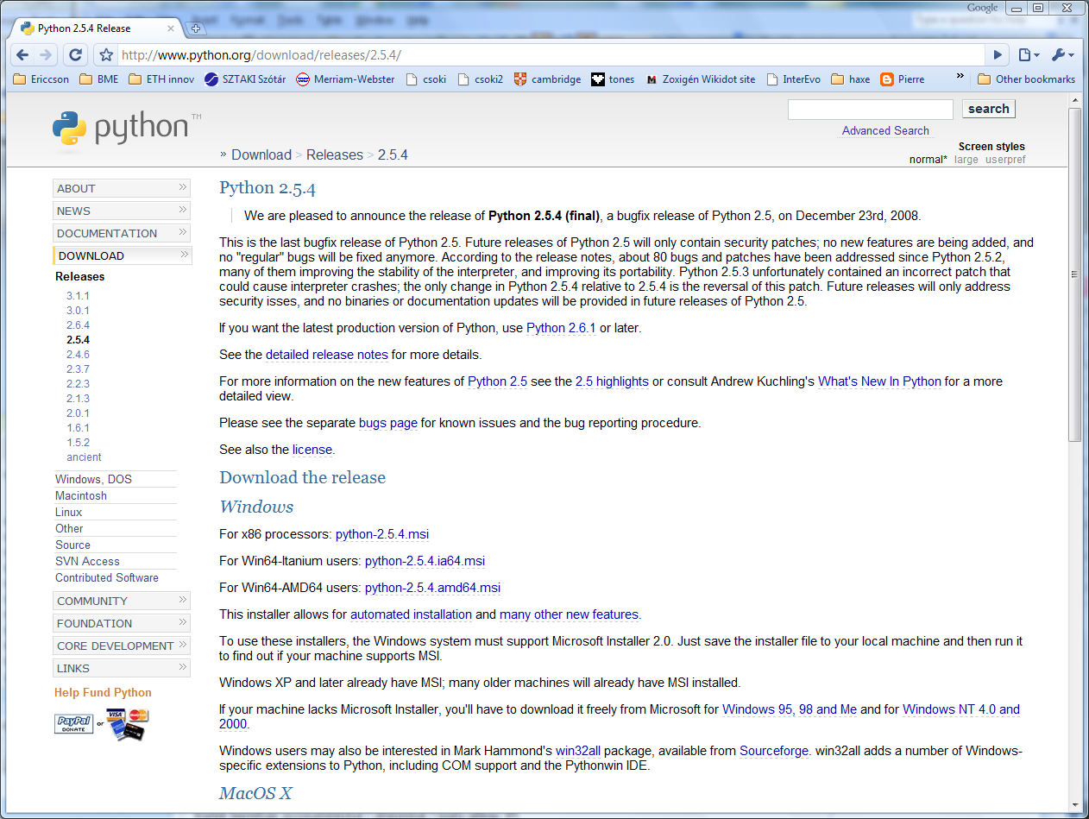

Then run the installer. Just use the default settings. The python will be installed to our hard drive, to the C:\Python25\ directory. Now we need to set the python program to be visible from anywhere in windows. For this, we need to make a right click on the Computer (“sajátgép” in Hungarian Windows) icon and selecting the “properties”. On the new dialog window let us chose the “Advanced system settings” link:

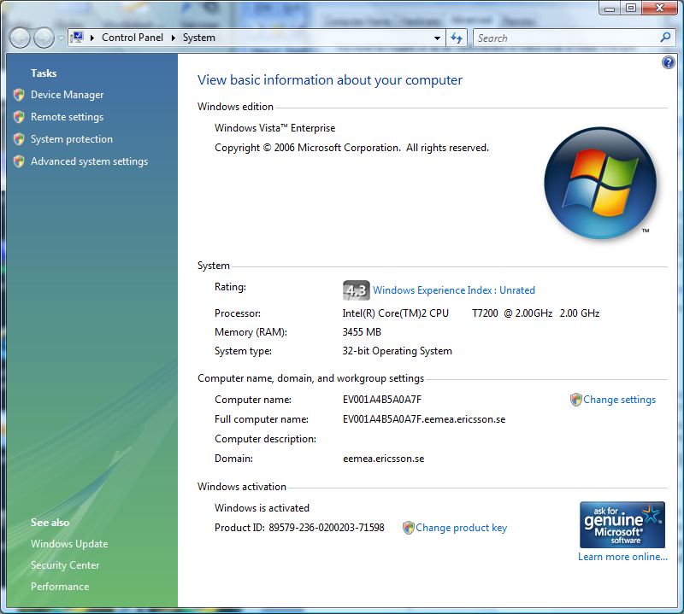

The “System Properties” window will show up. Let us click to the “Environment Variables” button on the “Advanced” tab:

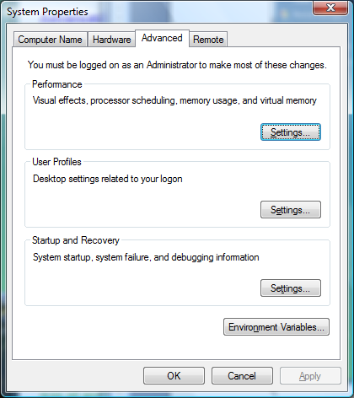

Now put the directory (“c:\python25”) contains the python binary files (like python.exe) to the beginning of environment variable Path. So click to the edit button when the Path variable among the System variables is highlighted:

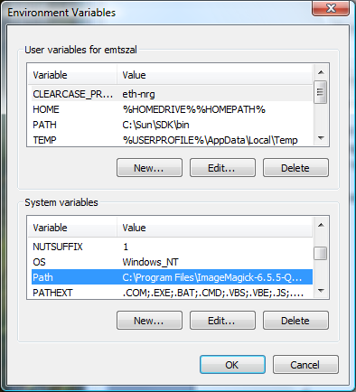

And insert the directory path and a “;” character to the beginning of the line:

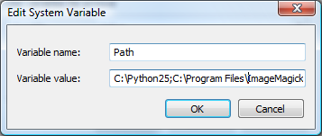

From now, if you are run the python command, the windows always will find the python program. Let we try it out – go to the Start menu / Run dialog and type “python”. You should see the following:

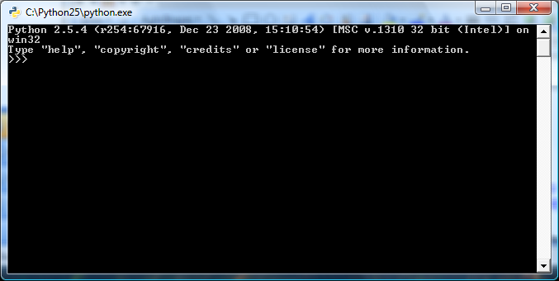

Now we will install the easyInstall program which helps us to download python modules easily. Go to the http://pypi.python.org/pypi/setuptools page, and download the windows install file for python 2.5:

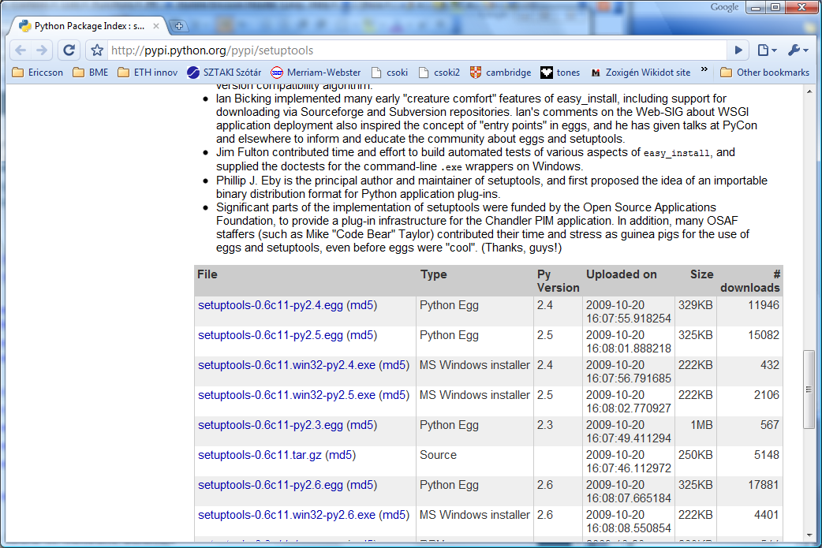

Install this program, we will use it later during the curse.

